Topic Modelling / Clustering of COS debates (PQ questions)
Data
Official Reports, Parliamentary Debates (Hansard) of the (last 5 parliaments) 14th Parliament (24-08-2020 to Present)
https://sprs.parl.gov.sg/search/#/home
Search this
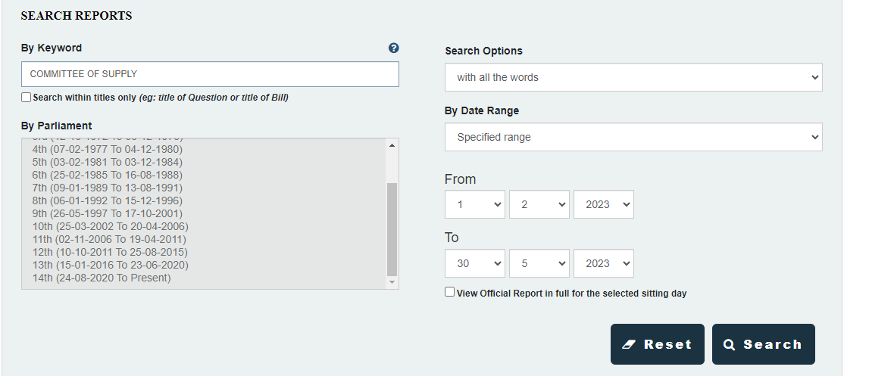
President’s address
https://sprs.parl.gov.sg/search/#/sprs3topic?reportid=president-address-2130
President’s address + All ministers
https://sprs.parl.gov.sg/search/#/fullreport?sittingdate=10-04-2023
Debate on President’s address
- https://sprs.parl.gov.sg/search/#/sprs3topic?reportid=president-address-2163
- https://sprs.parl.gov.sg/search/#/sprs3topic?reportid=president-address-2152
- https://sprs.parl.gov.sg/search/#/sprs3topic?reportid=president-address-2158
- https://sprs.parl.gov.sg/search/#/sprs3topic?reportid=president-address-2161
- https://sprs.parl.gov.sg/search/#/sprs3topic?reportid=president-address-2166
- https://sprs.parl.gov.sg/search/#/sprs3topic?reportid=president-address-2172

COS all ministries
- https://sprs.parl.gov.sg/search/#/sprs3topic?reportid=budget-2064 COS - MHA
- https://sprs.parl.gov.sg/search/#/sprs3topic?reportid=budget-2098 COS -MCCY
- https://sprs.parl.gov.sg/search/#/sprs3topic?reportid=budget-2099 COS - Parilment
- https://sprs.parl.gov.sg/search/#/sprs3topic?reportid=budget-2091 COS - MOH
- https://sprs.parl.gov.sg/search/#/sprs3topic?reportid=budget-2092 COS - MSF
- https://sprs.parl.gov.sg/search/#/sprs3topic?reportid=budget-2086 COS - MOT
- https://sprs.parl.gov.sg/search/#/sprs3topic?reportid=budget-2090 COS - MOT - Cont
- https://sprs.parl.gov.sg/search/#/sprs3topic?reportid=budget-2094 COS - MSF - Cont
- https://sprs.parl.gov.sg/search/#/sprs3topic?reportid=budget-2085 COS - MND - Note: Manually cleaned
- https://sprs.parl.gov.sg/search/#/sprs3topic?reportid=budget-2085 COS - MND
- https://sprs.parl.gov.sg/search/#/sprs3topic?reportid=budget-2084 COS - MSE -Cont
- https://sprs.parl.gov.sg/search/#/sprs3topic?reportid=budget-2079 COS - MSE
- https://sprs.parl.gov.sg/search/#/sprs3topic?reportid=budget-2078 COS - MOM - Note: Manually cleaned Patrick Tay (.. ):
- https://sprs.parl.gov.sg/search/#/sprs3topic?reportid=budget-2077 COS - MOE - Cont
- https://sprs.parl.gov.sg/search/#/sprs3topic?reportid=budget-2073 COS - MOE
- https://sprs.parl.gov.sg/search/#/sprs3topic?reportid=budget-2071 COS - MTI
- https://sprs.parl.gov.sg/search/#/sprs3topic?reportid=budget-2072 COS - MCI - Note: Mr Deputy Chairman/Speaker Manually cleaned
- https://sprs.parl.gov.sg/search/#/sprs3topic?reportid=budget-2063 COS - MFA
- https://sprs.parl.gov.sg/search/#/sprs3topic?reportid=budget-2065 COS - MOL
- https://sprs.parl.gov.sg/search/#/sprs3topic?reportid=budget-2054 COS MOD
- https://sprs.parl.gov.sg/search/#/sprs3topic?reportid=budget-2062 COS - MOD - Cont
- https://sprs.parl.gov.sg/search/#/sprs3topic?reportid=budget-2066 COS Judicature
- https://sprs.parl.gov.sg/search/#/sprs3topic?reportid=budget-2052 COS PMO
- https://sprs.parl.gov.sg/search/#/sprs3topic?reportid=budget-2053 COS MOF

Task
To explore common topics from COS debates that has taken place within the 14th Parliament.
- Write a web scraper to scrape the COS official reports from the Parliament website. Clean and preprocess your data.
- Unsupervised topic modelling: Find the most suitable number of topics of discussion for each Parliament (state the metric used and why). Do not use LDA method. Visualise the topics and show the impact of different words on the topic (see pyLDAviz for an example of topic visualisation)
- Every year, what is the most important topic of each parliament and how has it changed across each parliament? (Only doing 14th parliment)
- Identify the main themes within the President's address of each year and identify the top 10 related PQs to each of the themes for the year.

Find the main themes (extracted from MCI website) or the instana Newsroom
Find the top 10 PQ(Change to documents cause some PQ not exactly with ?) that are related to the themes
Do self-supervised clustering that is a classification based on already given
What other things that are covered?

Parliment is 3 years
https://maartengr.github.io/BERTopic/getting_started/semisupervised/semisupervised.html
https://www.istana.gov.sg/Newsroom/Speeches/2023/04/10/Speech-by-President-Halimah-Yacob-at-the-Opening-of-the-Second-Session-of-the-14th-Parliament

Which President's address themes align(KIV first discuss next Fri) closely to the PQs of the year and which do not?
-Can do topic modelling for clustering for no labels
-User have these terms already -> Can I do a clustering into the current terms?
- Predefined topics

- An example of the presidents address for 2023. You are encouraged to find other resources related to this address to aid in you task. https://www.istana.gov.sg/Newsroom/Speeches/2023/04/10/Speech-by-President-Halimah-Yacob-at-the-Opening-of-the-Second-Session-of-the-14th-Parliament
- Generate a title of each topic cluster each year + 300 word summary of each topic of discussion
- Identify which MPs frequently asked questions about each topic
Identify topic -> filter questions/clarifications -> trace back to the MP
Find out top MP(s) that ask about the topic
Try BERTTopic w/ BARD (for summarization)

Rachel review: 9th Nov
Topic 0 can split into further (May be education and manpower)
1) Force to cluster into 5 – 10 topics
2) Plot using a graph for coherence score
3) Circle further from another circle(subjective) or calculate overall coherence score (how dismilar the words are from each other)
4) For LDA: Search through a bunch of words

Cause there is a lot of extra things(i.e HDBScan, UMAP and SentenceTransformer)
Note: Understand things before using (ESP KeyBERTInspired, MaximalMarginalRelevance, PartOfSpeech)

1) How to optimse?
- Optimse UMAP first (best neighnour and components) -> Best dimension components??
- HDB Scan how to optimise- Run a few times – Find coherence score, or plot similarity
(KIV: Put to user call first)
- Stopwords, allow user to remove

2) Read up on KeyBERTInspired, MaximalMarginalRelevance, PartOfSpeech (DONE)

Summarisation(If got time) – PENDING NOT DONE
- Generate a Topic header: Dump all the words from top 3 represetation docs(Can change?) NOT POSSIBLE – need to change BERTopic source code
- Title generation(from top 3) – Try prompt engineering using LLM
- Try LLM(not only BARD and Pegasus) to summarise

Key findings for 17th November
PASTE your screenshots here and what you optimsed

Pointer from Aloysius + Wei Jie
b) Unsupervised topic modelling: Find the most suitable number of topics of discussion for each Parliament (state the metric used and why). Do not use LDA method. Visualise the topics and show the impact of different words on the topic (see pyLDAviz for an example of topic visualisation)
1. BERTopic
Define a range of topics or minimum topic sizes
per parliament how many times the minister spoke for all the mps

Find out COS dates every year
Part a 10th to 14th parliament COS Data per parliament how many times each mp spoke for COS

1 barchart per parliament 1 axis is the ministers name and the other axis is the no. of times they spoke. Write the barchart using matplotlib Python
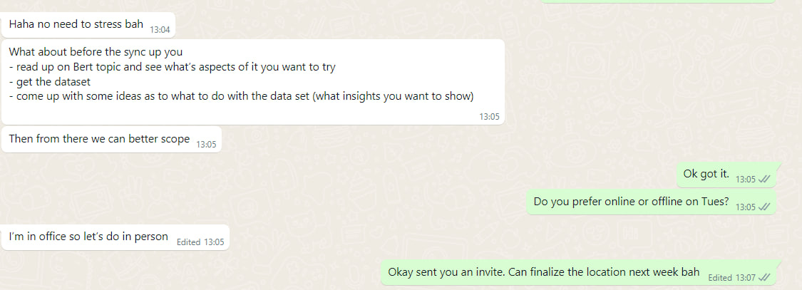
https://sprs.parl.gov.sg/search/#/sprs3topic?reportid=president-address-2130
Current Task Run BERTopic 3 week exploration -> Next Sprint next Wed -> Update what you have learnt
- My main purpose to better understand Topic modelling
- Share something to show with the team(for their learning as well) – how to set up the BERT Topic?

Pre-Task (From Wei Jie):
1) If use BERT Topic, what models/library to use?
2) Try BERT Topic on last year COS (How it aligns to the questions?)
-> Do on Jupyter notebook; say what data used on – Try to find top topics discussed -> Find Topics discussed from COS? b) and c)
Do we need to use open-source or fine-tuned? Usually open-sourced
In the future – Later on:
3) Propose to front-end or backend framework (standard can like follow the Vertext backend)
From Aloysius + Wei Jie
Currently LDA is based on word space similarities – clustering based on those things – doesnt really consider meaning -> BERT Topic would help with this limitations
- Some qns are quite challenging but that is why it is a 3 week exploration
- For a start look at BERT Topic first and try to answer the questions
- Not expecting to get gold
- Keep these questions in mind
- Develop new topic modelling algo

Additional task:
- Final goal: Through discussion, to build new feature within the current Vertext
HANDSAD https://sprs.parl.gov.sg/search/#/home
Explore BERT Topic in dataset - play around in textual data (Question a)
- Not crawled... need to crawl myself (Aloy says only last year COS Mar/Apr 2023)

e)
President address
- Based on COS discussion
- Attribute what the president say (maybe can use BERTopic?)

Presidential’s address before COS to set this theme for the government of the term to address
- Themes summarised by News article
Qns: Based on COS discussion, can we attribute to this topics discussed to whatever the President says?
Cluster to whatever the president says..
Can cluster by BERT Topic way but can use something else to match them
f) Generate a title of each topic cluster each year + 300 word summary of each topic of discussion
Suggest a title - Use any language model BERT or BARD or any transformer model?
BERTopics means BERT embeddings – use any embedding models – embedding space
Topic modelling in LDA has no title
BERTopic suggest some titles f)

g) Identify which MPs frequently asked questions about each topic
Normally what ministers ask

Context on task
HANDSAD https://sprs.parl.gov.sg/search/#/home
Parlimentary Seatings - 4 seatings in 4 years
Commitee of Supply - Every public agency need money - Public Servant ask questions to get enough money....
HANDSAD for topic modelling -> a lot of text

